Dan Holmes (s5304084)

S5304084@bournemouth.ac.uk

Portfolio website report

Digital Technologies Assignment

Contents

Introduction 2

Overview 2

Initial Specification 2

Design 2

Analysis 3

Home Page/index 4

Projects Page 4

Interests Page 5

Contact Page 5

Conclusion 6

References 6

# Introduction

This is the report concerning a web app developed in conjunction with the requirements for Digital Technologies Assignment 2 and will aim to describe and explain the development process used in the web apps creation, hopefully answering any questions one may have relating to said web app.

# Overview

This report will discuss all aspects of the creation of the website, including its specification, design, analysis of the finished website and final concluding thoughts, with the goal of detailing how the website was created and why specific methods and tools were used in its creation. This report will also discuss how successfully the website fulfilled its specification, problems encountered during development and what aspects could be added, changed, or fixed to improve the website and create a more enjoyable and accessible user experience.

# Initial Specification

The initial specification facilitated the design and development of a web application suitable for use as a portfolio, either for personal use or for a company. Said web app must be functional on as many typical web browsers as possible, and fill the required criteria of included features listed below:

* At least 3 different pages to navigate between
* At least one images and text on each page
* A consistent header and footer on multiple pages
* Use of an external CSS element
* Timed slideshow of screenshots or photos
* Interactive menubar to allow users to navigate the site more effectively

# Design

To start with, there are some requirements for how the web pages can be designed from the specification, with it stating that all the pages of the website feature a consistent header and footer to create a uniform look amongst them. Along with this an interactive menubar is also requested as a part of the web pages that make up the website to give at least some form of user interaction with the pages, even when none is required for a page to fulfil its purpose. Below you will see examples of both these requirements being fulfilled.

**Header and footer:**

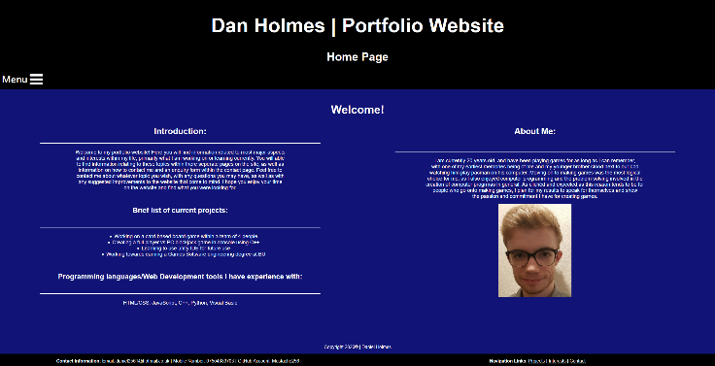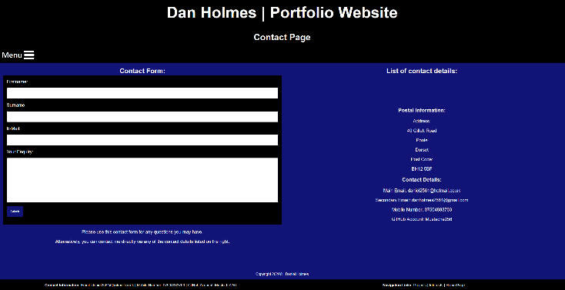

Header

Footer

**Interactive Menubar:**

Each page of the site is designed to be simplistic, uniform, and easy to look at to help create the most straightforward and enjoyable user experience. Each page follows the same 3 tone colour scheme of black, white, and blue to make every page look as if they belong to the same website, assisted by the specified requirements discussed above. The appearance of the pages also means that users eyes will be drawn images and other items of importance, as they are able to pop out amongst the otherwise darkened colours of the web page.

Each of the pages are able to be accessed from anywhere on the site, through both the interactive menubar and the navigation links within the footer, giving users ease of navigation to anywhere on the site, and making every page interconnected as represented on the diagram below:

# Analysis

To preface, all of the 4 webpages that the website contains fit within the required specifications listed previously, as well as fulfilling their purposes to a satisfactory degree. This analysis will mainly be focusing on how well each page fulfils both the specification requirements and their own purpose and therefore determine what could be added to improve the pages.

## Home Page/index

The purpose of this page is to give a brief introduction to new users and give them an idea as to what they will find within the website. The amount of information it gives is satisfactory, as to not overwhelm users with information that can be found in more depth on other pages of the site, however this is room for more additional information if needed. The page also has a lack of interactive elements, other than the menubar for navigation, making the addition of some other form of user interaction a potential improvement to consider.

## A picture containing text, screenshot, screen Description automatically generatedProjects Page

Again, like the page previously discussed, the amount of information given within this page is satisfactory to inform users as to current projects. However, this page makes its table format visible for the user to aid with understanding the information presented to them, with this kind of formatting allowing room for potential additions and removals from the page as projects change. This page also suffers from the same lack of interactive features that the home page does, so that aspect serves as the major consideration for improving the page.

## Interests Page

Unlike the previous 2 pages, this page features an interactive slideshow that the user is able to control using either the 2 arrow buttons or the circular buttons to select what image they would like to view. Each of the images relates to one of the written paragraphs within the page, giving visual aids to each of the games described. The structure of page also allows for the addition of more content if needed, with adding more to the page being the one major improvement the page may need.

## A screenshot of a computer Description automatically generatedContact Page

This page, out of all the pages discussed, has the least information within its content, but doesn’t require a large amount of information to fulfil its purpose, of which it does. This page does however feature an interactive element with the contact form, the error checking taken from a previously created website that will be included with this report. In spite of this error checking, the contact form is but a façade as it doesn’t send the information anywhere, so the major improvement that would need to be made to this page would be making it so that the contact form functions and sends the information entered to it to a receiver location.

# Conclusion

Overall, the website fulfils all the specification requires, as well as the personal design requirements it had set for itself, all the pages look uniform and like they belong with each providing the required information to fulfil their purpose. However, the overall colour scheme for the website, whilst being easy to look at, isn’t very interesting and doesn’t take into consideration accessibility for people who have some form of visual impairment. To that end, along with the improvements discussed in the analysis, adding accessibility options and a more interesting colour scheme for the site are some of the improvements that can be made.

# References

HTML/CSS/JS Image slideshow [online]. W3Schools. Available from: <https://www.w3schools.com/howto/howto_js_slideshow.asp> [Accessed 15 September 2020]

HTML/CSS/JS Contact form [online]. W3Schools. Available from: <https://www.w3schools.com/howto/howto_css_contact_form.asp> [Accessed 14 September 2020]

W3Schools. Available from: <https://www.w3schools.com/> [Accessed 15 September 2020]